Assignment #1

# Issued: 2 April 2020 Due: 20 April 2020 (at 23h59, eastern standard time)

Please read each question carefully, be careful with units, and answer *all* parts. All figures must be clearly labeled: axes include variables being plotted and their units as necessary. Show your work, including the equations used, scripts used for numerical calculations, and any Smith charts you may have used.

**Antoine Wang 260766084**

**1. In this question, you will study reflection at normal incidence from multi-layered media. Consider two media:**

1. **= air, with the material properties σ = 0, ε = ε0 , μ = μ0**
2. **= plastic, with the material properties σ = 0, ε = 3ε0 , μ = μ0**

**For simplicity, assume that all material parameters are independent of frequency.**

1. **What is the reflection coefficient Γ for a normally incident wave from material A to material B? What is the reflection coefficient Γ for a normally incident wave from material B to material A? [2pts]**

From A to B:

Γ =

From B to A:

Γ =

1. **Calculate the reflection coefficient Γ for an ABA structure as shown below, with the layer thickness d1 = 0.010 m, for the frequency range 0 < f < 10 GHz with frequency steps of Δf = 0.05 GHz. Plot the resulting reflection amplitude |Γ| versus frequency f. [2pts]**

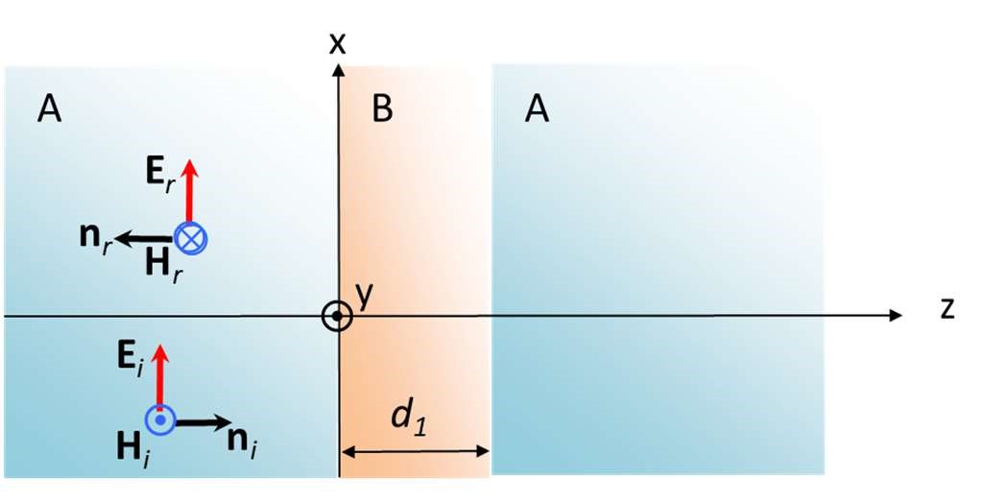

Procedure:

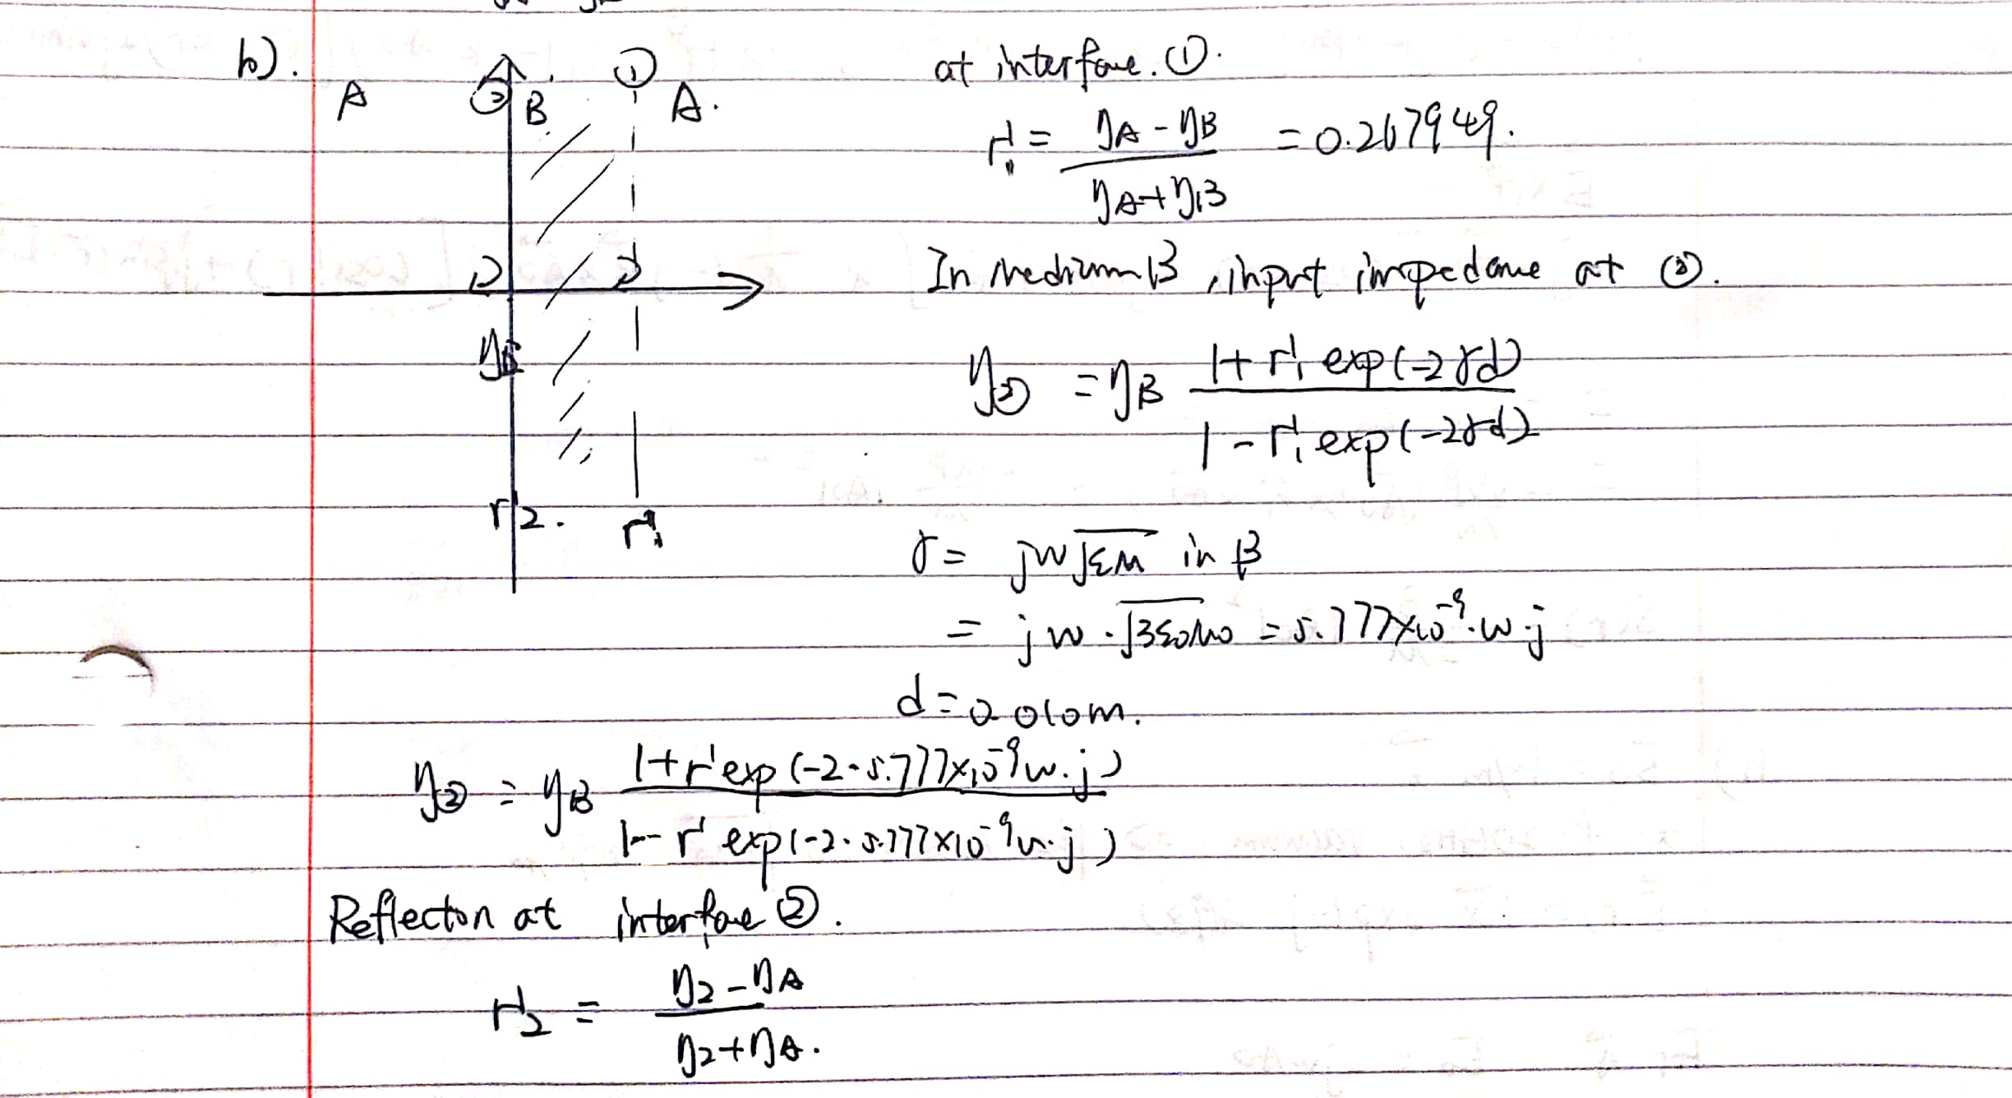

Coding of the solution in MATLAB:

clear; close all;

freq =0:0.05e9:10e9;

nb = 377/sqrt(3);

na = 377;

reCoefficient1 = 0.267949;

beta = 5.777e-9;

impedence = zeros(length(freq));

reCoefficient2 = zeros(length(freq));

for k=1: length(freq)

impedence(k) = nb .* (1+reCoefficient1.*exp(-2j.*beta.*(2*pi).*freq(k).*0.01))./(1-reCoefficient1.*exp(-2j.*beta.*(2*pi).*freq(k).*0.01));

reCoefficient2(k) = abs((impedence(k) - na)/(impedence(k) + na));

end

plot(freq,reCoefficient2)

title('Plot of reflection amplitude, question 1.b')

Plotting:

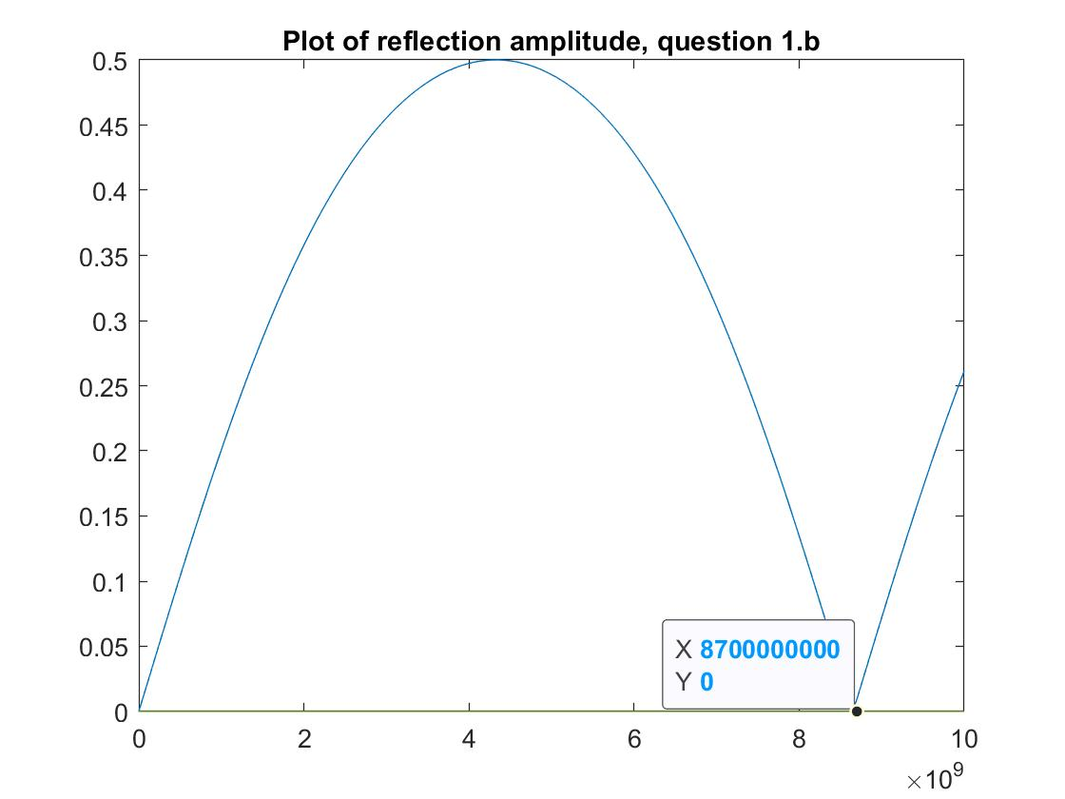

1. **Consider your answer to part b). What is the lowest frequency f where the thickness d1 is equal to λ/2 in layer B (ie. layer B acts as a ½ wave plate) ? What is the lowest frequency f where the thickness d1 is equal to λ/4 in layer B (ie. layer B acts as a ¼ wave plate) ? [2pts]**

According to the plotting in B, the lowest frequency of ½ wave frequency is 8.7Ghz. The reason is that the reflection coefficient reaches zero due to a ABA structure.

The lowest frequency for the thickness of b to be ¼ wavelength is thus 4.35Ghz, half of that of ½ wavelength frequency.

1. Calculate the reflection coefficient Γ for an ABABA structure as shown below, with the layer thickness d1 = 0.010 m and d2 = 0.017 m for the frequency range 0 < f < 10 GHz with frequency steps of Δf = 0.05 GHz. Plot the resulting reflection amplitude |Γ| versus frequency f. [2pts]

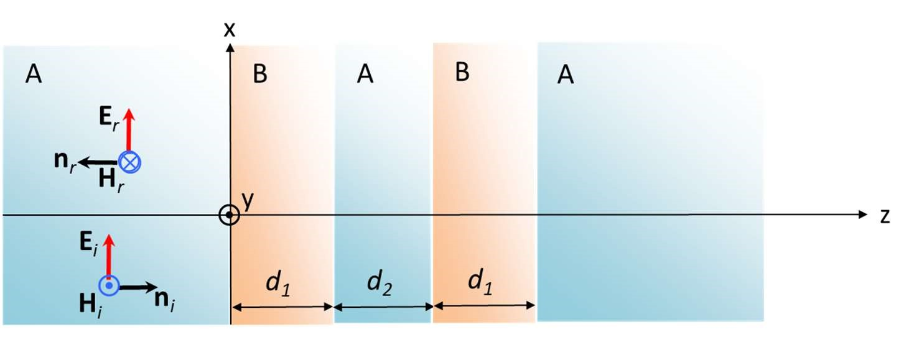

Solution:

This structure is simply adding another AB layer to the left of the original ABA structure. Thus in MATLAB code simulating the procedure, adding two extra steps in d2 of A and d1 of B simulates the condition of this question.

MATLAB code:

freq =0:0.02e9:10e9;

nb = 377/sqrt(3);

na = 377;

reCoefficient1 = 0.267949;

betaB = 5.777e-9;

betaA = 3.333e-9;

impedenceB1 = zeros(length(freq));

impedenceB2 = zeros(length(freq));

impedenceA = zeros(length(freq));

reCoefficient2 = zeros(length(freq));

reCoefficient3 = zeros(length(freq));

reCoefficient4 = zeros(length(freq));

for k=1: length(freq)

% Original ABA---------------

impedenceB1(k) = nb .* (1+reCoefficient1.*exp(-2j.*betaB.*(2*pi).*freq(k).*0.01))./(1-reCoefficient1.*exp(-2j.*betaB.*(2*pi).*freq(k).*0.01));

reCoefficient2(k) = (impedenceB1(k) - na)/(impedenceB1(k) + na);

% Adding additional A of 0.17m--------

impedenceA(k) = na .* (1+reCoefficient2(k).*exp(-2j.*betaA.*(2*pi).*freq(k).*0.017))./(1-reCoefficient2(k).*exp(-2j.*betaA.*(2*pi).*freq(k).*0.017));

reCoefficient3(k) = (impedenceA(k) - nb)/(impedenceA(k) + nb);

% repeat with a B layer of 0.1m

impedenceB2(k) = nb .* (1+reCoefficient3(k).*exp(-2j.*betaB.*(2*pi).*freq(k).*0.01))./(1-reCoefficient3(k).*exp(-2j.*betaB.*(2*pi).*freq(k).*0.01));

reCoefficient4(k) = abs((impedenceB2(k) - na)/(impedenceB2(k) + na));

end

plot(freq,reCoefficient4)

title('Plot of reflection amplitude, question 1.d');

Plot:

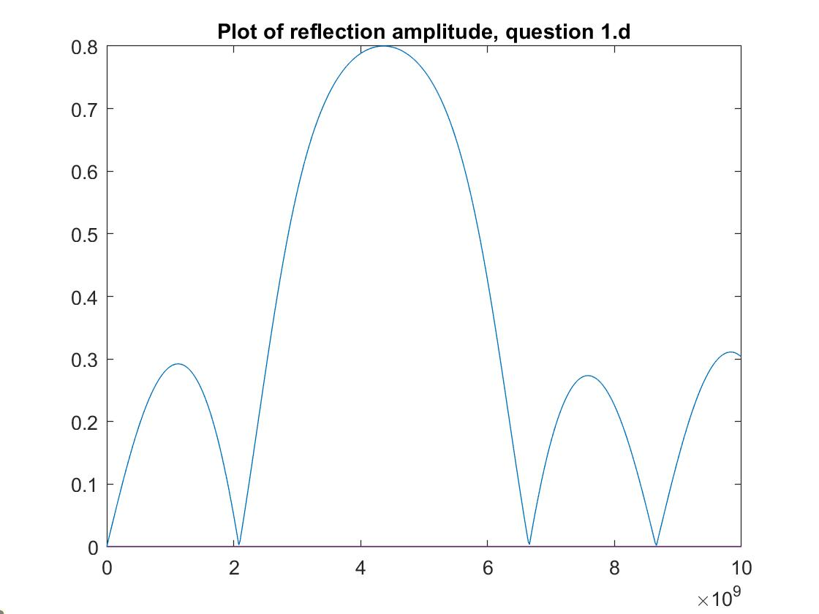

1. Calculate the reflection coefficient Γ for an ABABABA structure as shown below, with the layer thickness d1 = 0.010 m and d2 = 0.017 m, for the frequency range 0 < f < 10 GHz with frequency steps of Δf = 0.05 GHz. Plot the resulting reflection amplitude |Γ| versus frequency f. [2pts]

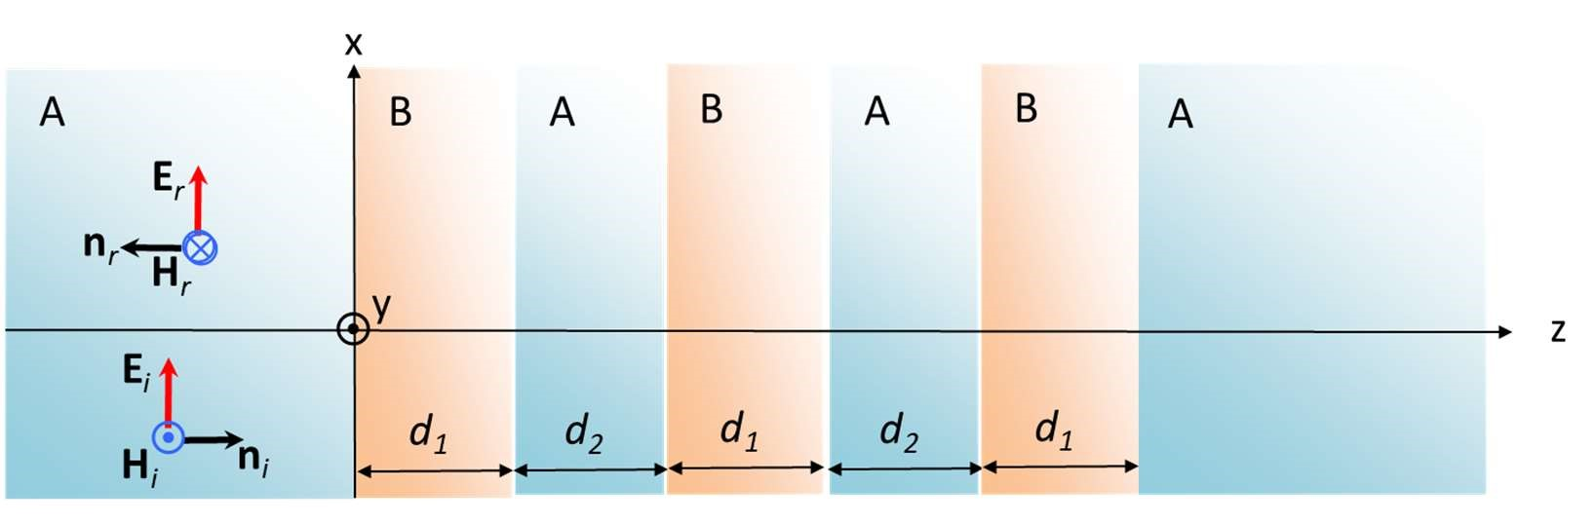

Solution:

Repeat the procedure of 1.d by adding another AB layer to the ABABA structure.

Matlab code:

freq =0:0.02e9:10e9;

nb = 377/sqrt(3);

na = 377;

reCoefficient1 = 0.267949;

betaB = 5.777e-9;

betaA = 3.333e-9;

impedenceB1 = zeros(length(freq));

impedenceB2 = zeros(length(freq));

impedenceA = zeros(length(freq));

reCoefficient2 = zeros(length(freq));

reCoefficient3 = zeros(length(freq));

reCoefficient4 = zeros(length(freq));

for k=1: length(freq)

impedenceB1(k) = nb .* (1+reCoefficient1.*exp(-2j.*betaB.*(2*pi).*freq(k).*0.01))./(1-reCoefficient1.*exp(-2j.*betaB.*(2*pi).*freq(k).*0.01));

reCoefficient2(k) = (impedenceB1(k) - na)/(impedenceB1(k) + na);

impedenceA(k) = na .* (1+reCoefficient2(k).*exp(-2j.*betaA.*(2*pi).*freq(k).*0.017))./(1-reCoefficient2(k).*exp(-2j.*betaA.*(2*pi).*freq(k).*0.017));

reCoefficient3(k) = (impedenceA(k) - nb)/(impedenceA(k) + nb);

impedenceB2(k) = nb .* (1+reCoefficient3(k).*exp(-2j.*betaB.*(2*pi).*freq(k).*0.01))./(1-reCoefficient3(k).*exp(-2j.*betaB.*(2*pi).*freq(k).*0.01));

reCoefficient4(k) = (impedenceB2(k) - na)/(impedenceB2(k) + na);

% from this point we are adding a additional AB layer on to ABABA

% structure in Question d

impedenceA(k) = na .* (1+reCoefficient4(k).*exp(-2j.*betaA.*(2*pi).*freq(k).*0.017))./(1-reCoefficient4(k).*exp(-2j.*betaA.*(2*pi).*freq(k).*0.017));

reCoefficient3(k) = (impedenceA(k) - nb)/(impedenceA(k) + nb);

impedenceB2(k) = nb .* (1+reCoefficient3(k).*exp(-2j.*betaB.*(2*pi).*freq(k).*0.01))./(1-reCoefficient3(k).*exp(-2j.*betaB.*(2*pi).*freq(k).*0.01));

reCoefficient4(k) = abs((impedenceB2(k) - na)/(impedenceB2(k) + na));

end

plot(freq,reCoefficient4)

title('Plot of reflection amplitude, question 1.e')

Plot:

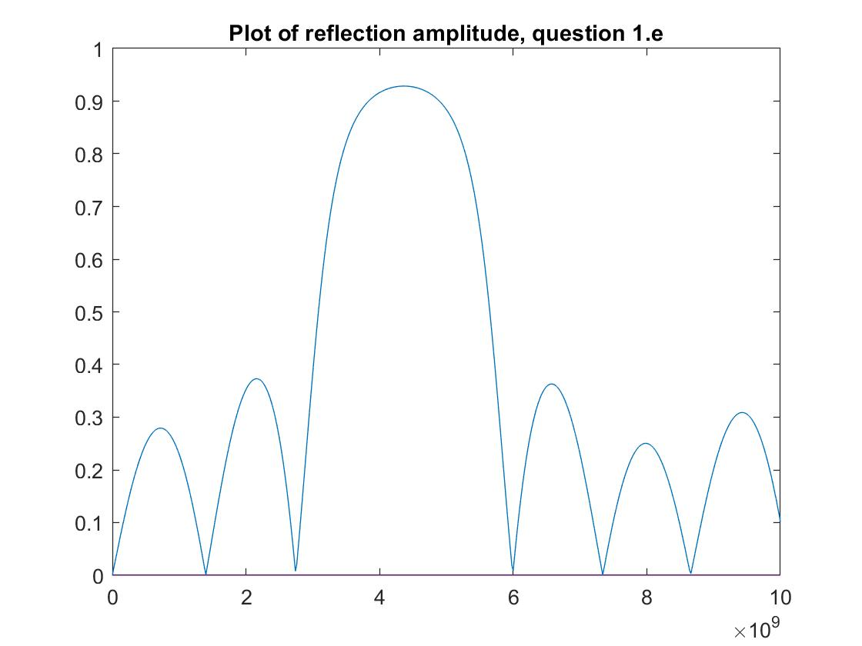

Optional exercise for self-education beyond ECSE 354 (no marks): Derive an analytical formula for the reflection coefficient Γ for an arbitrarily long stack A(BA)n = A BA BA BA …. BA structure for n ≥ 1.

2. In this question, you will consider the properties of a WR28 hollow metallic waveguide. The waveguide dimensions are a = 7.11 mm and b = 3.56 mm. The inner walls of the waveguide are gold plated, with a conductivity σ = 4.1 x 107 S/m and a permeability μ = μ0. The waveguide is filled with air, which can be approximated as vacuum. Recall the vacuum speed of light is c = (ε0μ0)-1/2.

1. **What is the cut-off frequency fc for the TE10 mode? [1pt]**

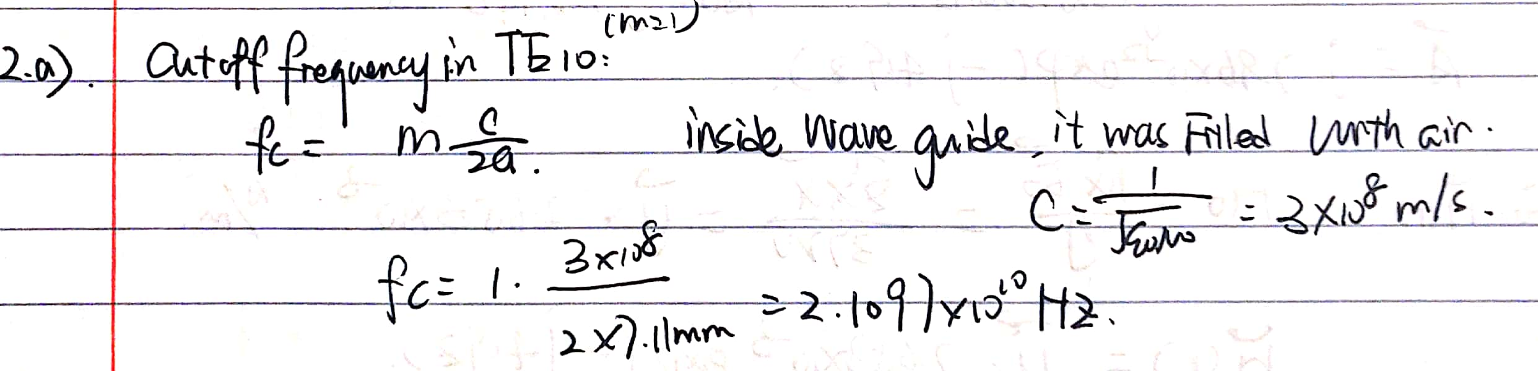

1. **Calculate the angle of incidence θ for the TE10 mode, as defined in the plane wave picture of TEm0 modes, for the frequency range fc < f < 2fc . Plot θ versus f. [2pts]**

Matlab code:

%calculating the cutoff frequency

fc = 1*3e8/2/7.11e-3;

freq =fc:0.05e9:2*fc;

cos_incident = zeros(length(freq));

incident = zeros(length(freq));

for k=1: length(freq)

cos_incident(k) = (pi/7.11e-3)/(2*pi*freq(k)*3.33e-9);

incident(k) = acosd(cos_incident(k));

end

plot(freq,incident)

Plot:

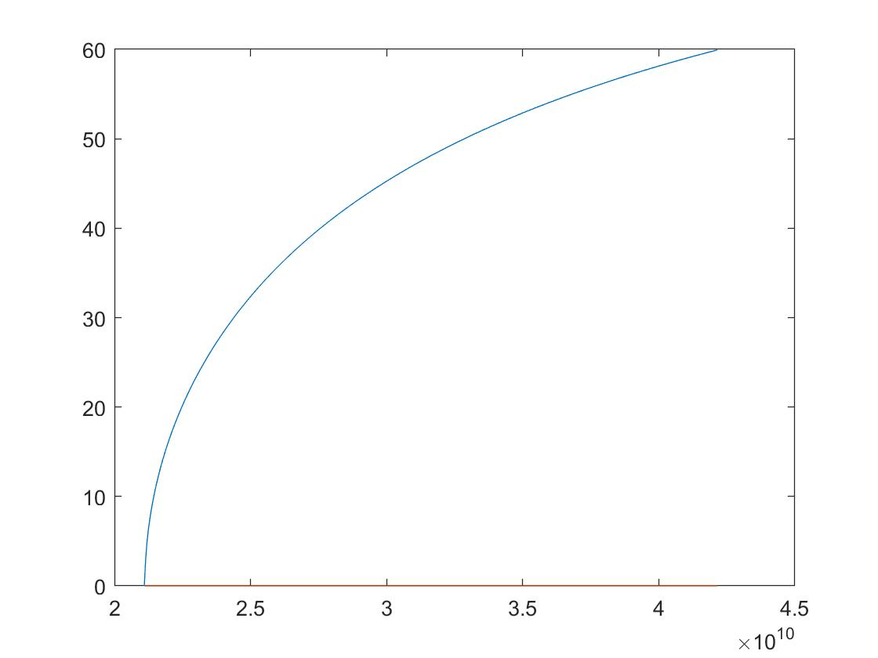

1. **Calculate the phase constant β = kz for the TE10 mode, as defined in the plane wave picture, for the frequency range fc < f < 2fc . Plot cβ/ω versus f. [2pts]**

Matlab code:

%calculating the cutoff frequency

fc = 1*3e8/2/7.11e-3;

freq =fc:0.05e9:2*fc;

beta = zeros(length(freq));

cb_w = zeros(length(freq));

for k=1: length(freq)

beta(k) = 2*pi*freq(k)/3e8*sqrt(1 - (fc^2 / freq(k)^2));

cb_w(k) = beta(k)*3e8/2/pi/freq(k);

end

plot(freq,cb_w)

title('Plot of question 2.c')

Plot:

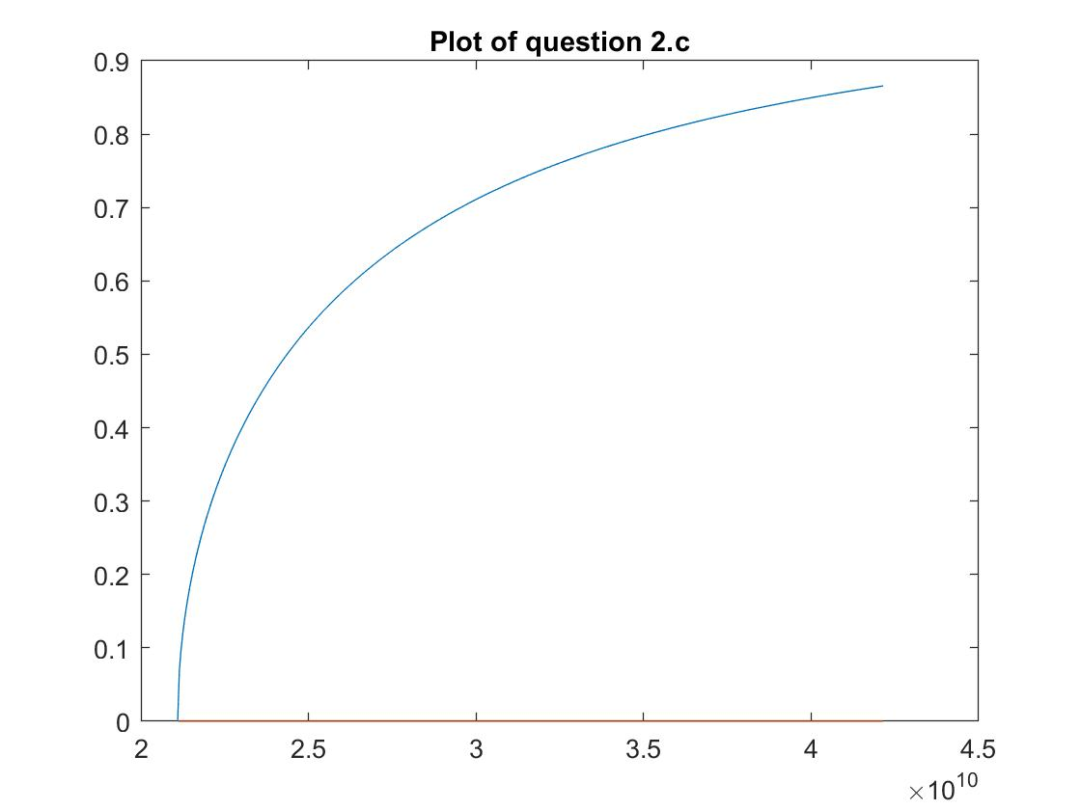

1. **Calculate the phase velocity vp for the TE10 mode for the frequency range fc < f < 2fc . Plot vp/c versus f. [2pts]**

Matlab code:

%calculating the cutoff frequency

fc = 1*3e8/2/7.11e-3;

freq =fc:0.05e9:2*fc;

betacb_w = zeros(length(freq));

vp_c = zeros(length(freq));

for k=1: length(freq)

betacb_w(k) = sqrt(1 - (fc^2 / freq(k)^2));

vp_c(k) = 1/betacb_w(k);

end

hold on

plot(freq,vp_c)

title('Plot of phase velocity, question 2.d')

Plot:

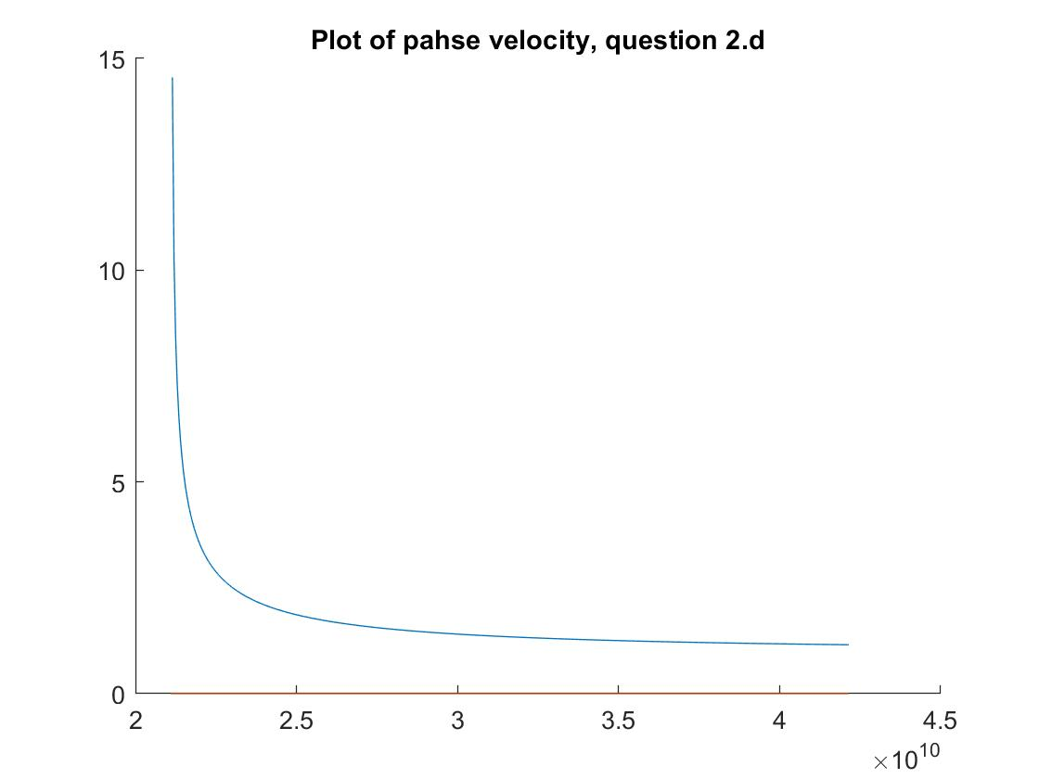

1. **Calculate the group velocity vg for the TE10 mode for the frequency range fc < f < 2fc . Plot vg/c versus f. [2pts]**

Matlab code:

%calculating the cutoff frequency

fc = 1*3e8/2/7.11e-3;

freq =fc:0.05e9:2*fc;

% vg = dw/db

% the formula is c*sqrt(1 - (fc^2 / freq(k)^2))

vg_c = zeros(length(freq));

for k=1: length(freq)

vg_c(k) = sqrt(1 - (fc^2 / freq(k)^2));

end

hold on

plot(freq,vg_c)

title('Plot of group velocity, question 2.e')

Plot:

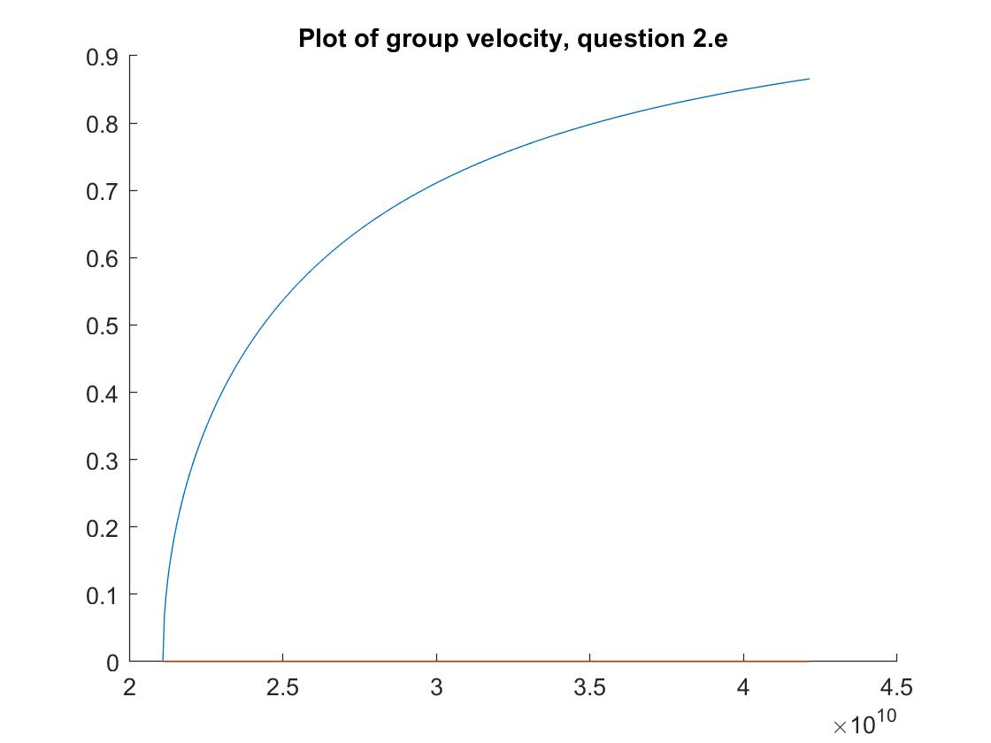

1. **Calculate the sheet resistance Rs for gold for the frequency range fc < f < 2fc . Plot Rs versus f.**

Matlab code:

%calculating the cutoff frequency

fc = 1*3e8/2/7.11e-3;

freq =fc:0.05e9:2*fc;

mu = 4e-7*pi;

sigma = 4.1e7;

Rs = zeros(length(freq));

for k=1: length(freq)

Rs(k) = sqrt(pi*mu*freq(k)/sigma);

end

plot(freq,Rs)

title('Plot of Rs, question 2.f')

Plot:

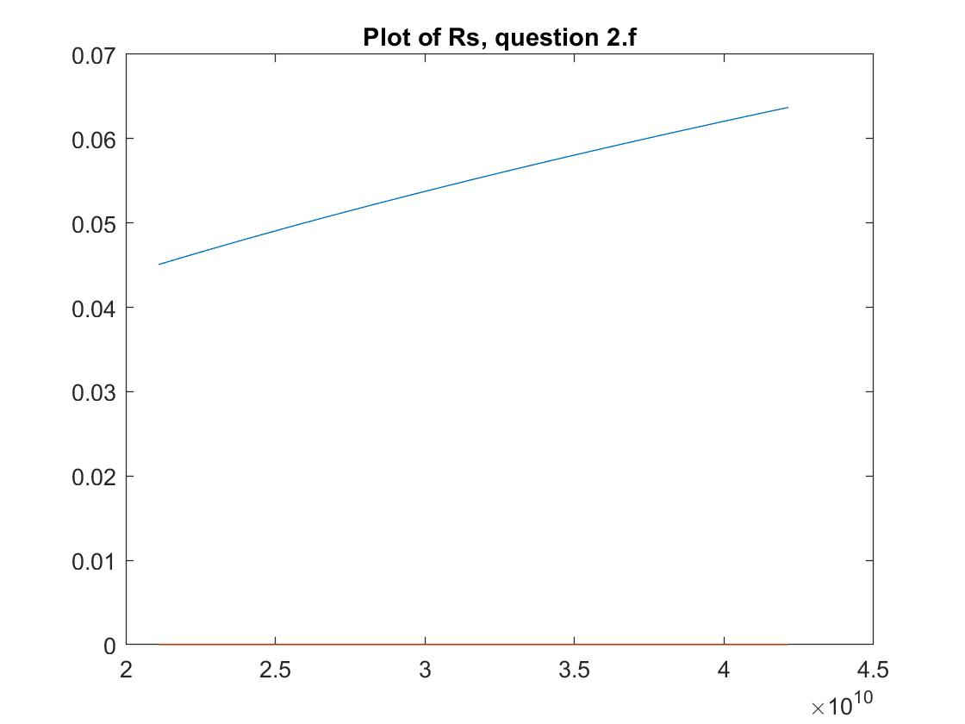

1. **Calculate the attenuation constant α for the TE10 mode for the frequency range fc < f < 2fc . Plot α versus f. [2pts]**

Matlab code:

%calculating the cutoff frequency

fc = 1*3e8/2/7.11e-3;

freq =fc:0.05e9:2*fc;

mu = 4e-7*pi;

sigma = 4.1e7;

Rs = zeros(length(freq));

alpha = zeros(length(freq));

vg = zeros(length(freq));

for k=1: length(freq)

Rs(k) = sqrt(pi*mu*freq(k)/sigma);

vg(k) = 3e8*sqrt(1 - (fc^2 / freq(k)^2));

alpha(k) = Rs(k)*(1/3.56e-3+2*(fc^2 / freq(k)^2)/7.11e-3)/ mu/ vg(k);

end

plot(freq,alpha)

title('Plot of alpha, question 2.g')

Plot:

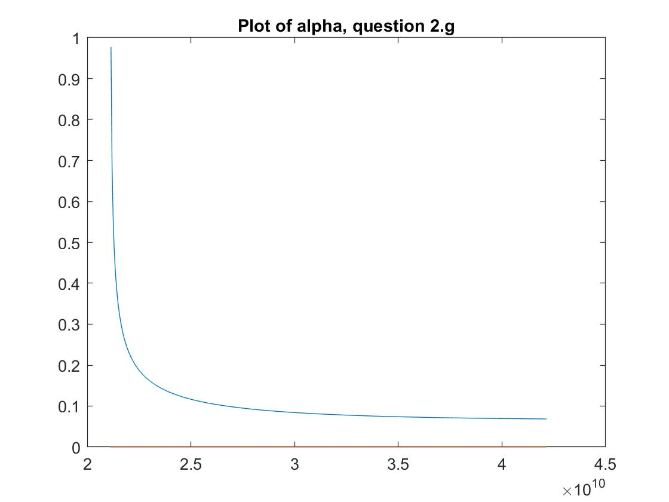

1. **Calculate the loss tangent tan(δD) for the frequency range fc < f < 2fc . Plot tan(δD) versus f. [2pts]**

Matlab code:

%calculating the cutoff frequency

fc = 1*3e8/2/7.11e-3;

freq =fc:0.05e9:2*fc;

beta = zeros(length(freq));

Rs = zeros(length(freq));

alpha = zeros(length(freq));

vg = zeros(length(freq));

tan_delta = zeros(length(freq));

mu = 4e-7*pi;

sigma = 4.1e7;

for k=1: length(freq)

beta(k) = 2*pi*freq(k)/3e8*sqrt(1 - (fc^2 / freq(k)^2));

Rs(k) = sqrt(pi*mu*freq(k)/sigma);

vg(k) = 3e8*sqrt(1 - (fc^2 / freq(k)^2));

alpha(k) = Rs(k)*(1/3.56e-3+2*(fc^2 / freq(k)^2)/7.11e-3) / mu / vg(k);

% Good dielectric approximation links alpha, beta and loss tangent

% together

tan_delta(k) = 2*alpha(k)/beta(k);

end

plot(freq,tan_delta)

title('Plot of question 2.h')

Plot:

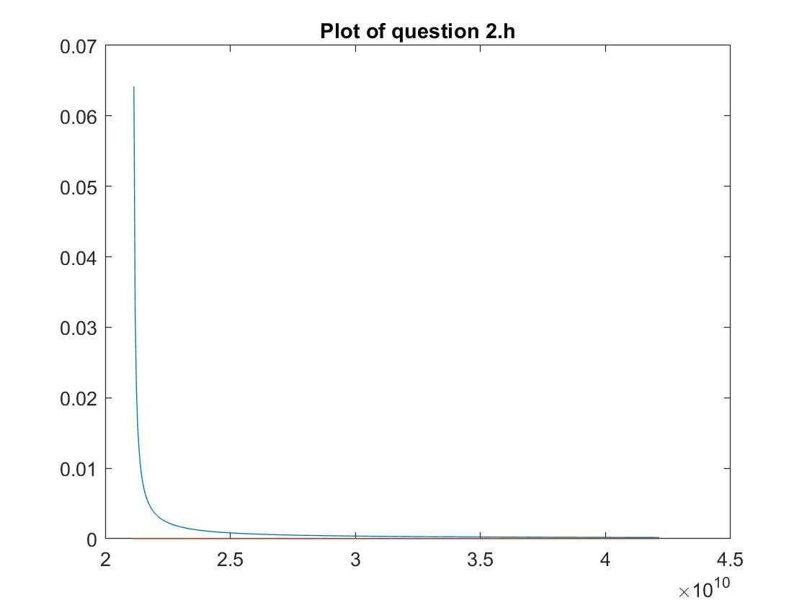

Optional exercise for self-education beyond ECSE 354 (no marks): Consider a closed rectangular metal box with dimension a in the x direction, b in the y direction, and c in the z direction. Assume c = a, a > b, the walls are perfect electric conductors, and the interior is filled with air. This is called a resonant cavity. Derive an analytical formula for the lowest frequency solution E(x,y,z) and the corresponding frequency fc of this solution.

**3. In this question, you will explore the vector potential A with the Lorenz gauge condition.**

1. **Consider a plane wave propagating in a lossless medium. Give an expression for the time average Poynting vector in terms of the vector potential phasor A, wavevector k, and physical constants as necessary. [1½ pts]**

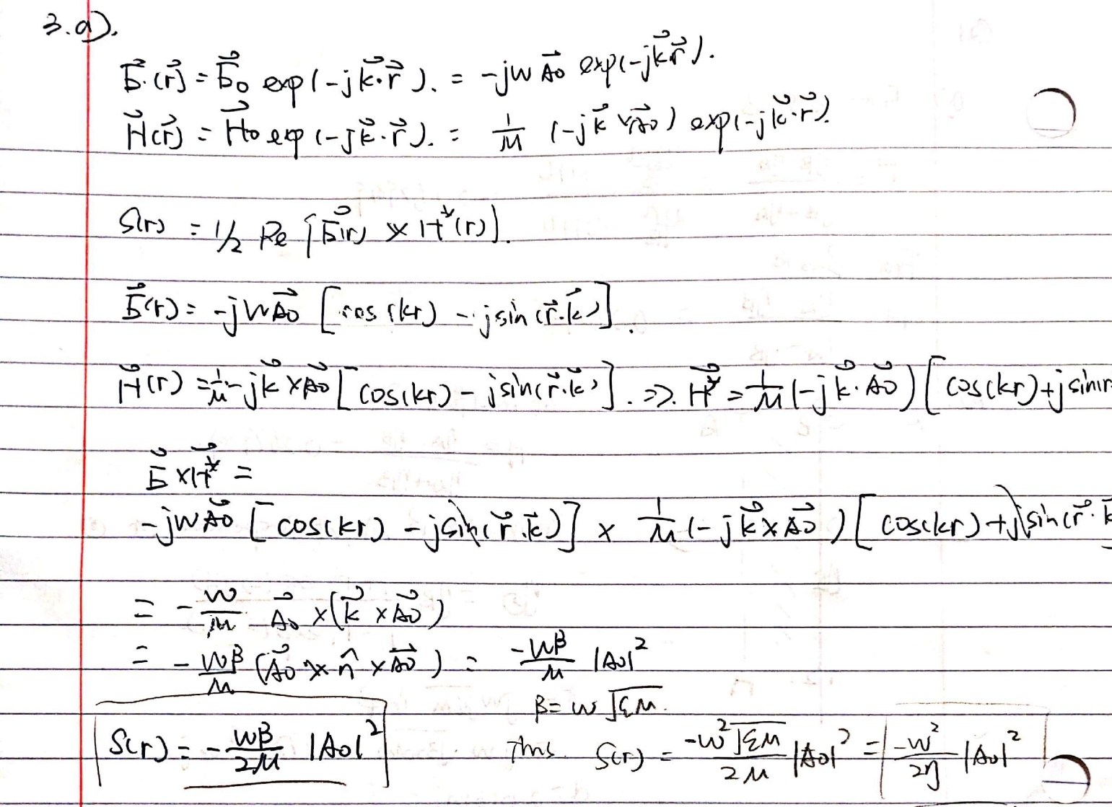

Poynting vector Is in the same direction as the wave propagates, thus

1. **A plane wave is propagating in vacuum in the +z direction at a frequency f = 20 GHz with electric field linearly polarized in the x-direction with 1 V/m amplitude. Give the phasor expressions for the vector potential A, electric field E, and magnetic field H. [1½ pts]**

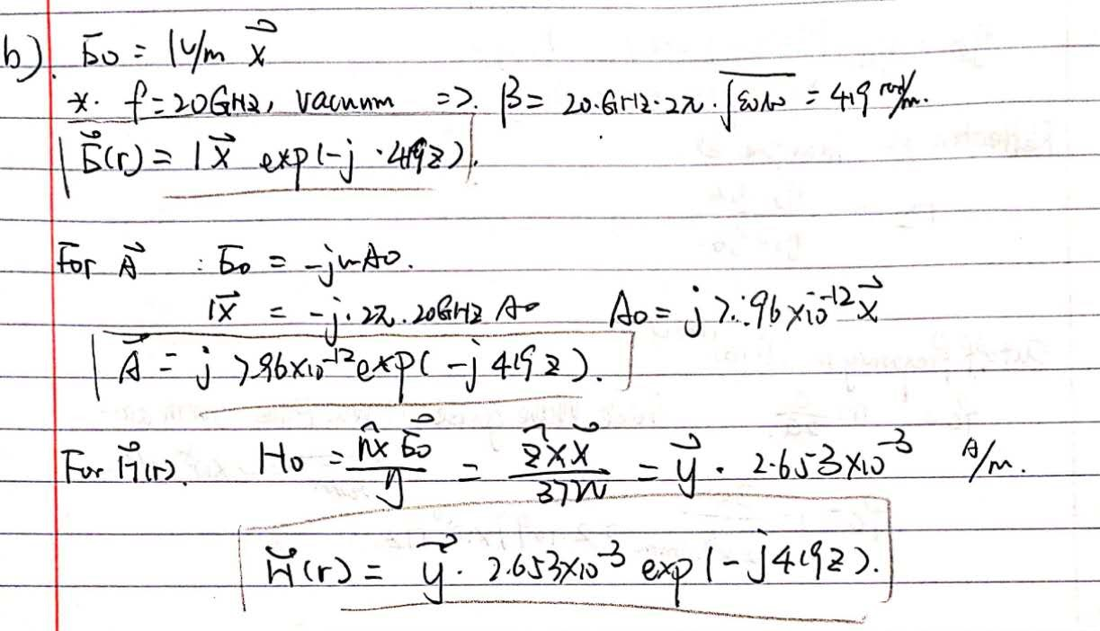

1. **A plane wave is propagating in vacuum in the +z direction at a frequency f = 20 GHz with electric field circularly polarized ( polarization vector 𝐚 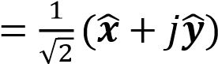 ) with 1 V/m amplitude. Give the phasor**

**expressions for the vector potential A, electric field E, and magnetic field H. [1½ pts]**

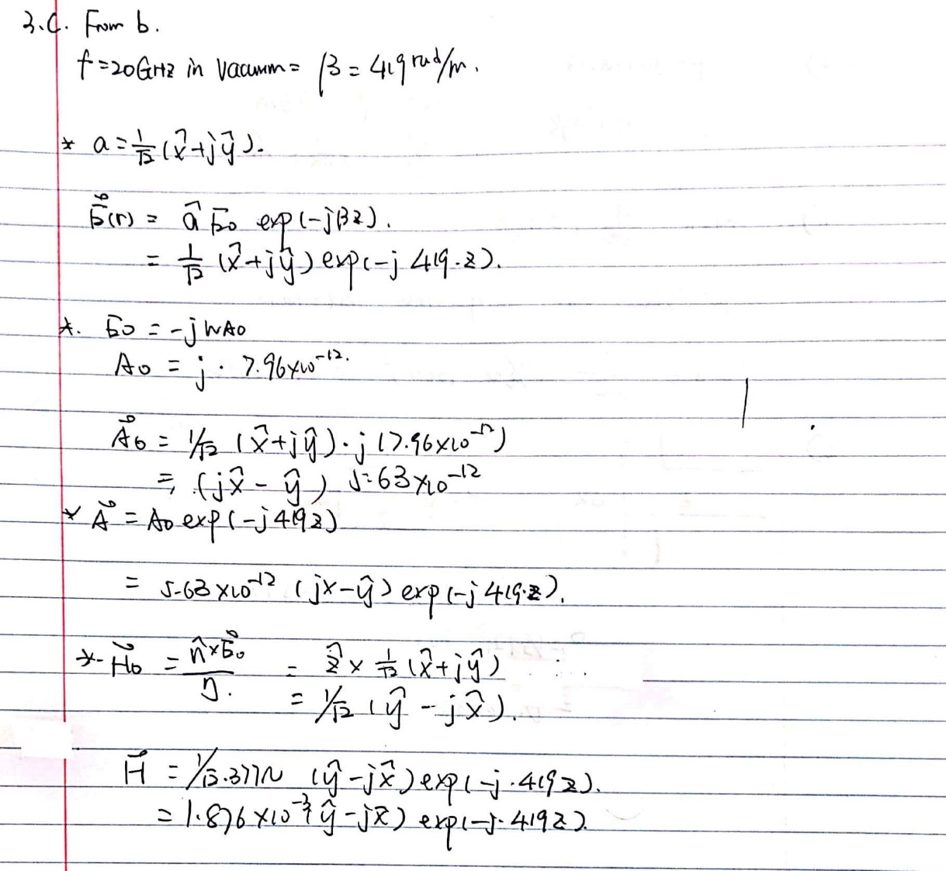

1. **Consider two plane waves at a frequency f = 20 GHz propagating in vacuum, one in the +z direction with electric field polarization vector 𝐚 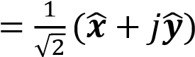 and another in the -z direction with electric field polarization vector 𝐚 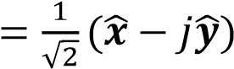, and each with a 1 V/m electric field amplitude. Give the phasor expressions for the total vector potential A, total electric field E, and total magnetic field H. [1½ pts]**

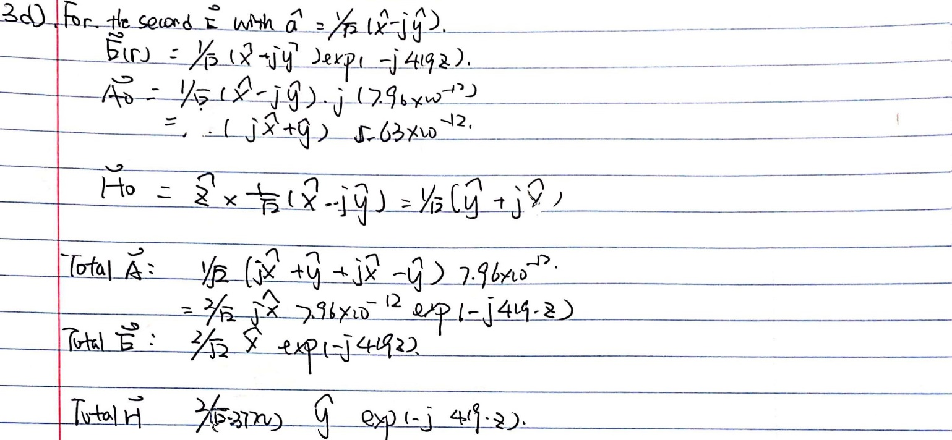

Optional exercise for self-education beyond ECSE 354 (no marks): Ampere’s law can be easily used to derive the magnetic flux density B around a wire carrying a dc current I0. Find a vector potential A that leads to the magnetic flux density 𝐁 = ∇ × 𝐀 in this problem. Can you derive this vector potential from a current integral? (warning: this problem is deceptively simple, but rather advanced)

**4. Consider a dipole antenna of length Δℓ = 10 cm operating at a frequency f = 500 MHz. Approximate the dipole antenna behavior as that of a Hertzian dipole. Air is the surrounding medium and conductor resistance can be neglected.**

1. **What is the ratio of antenna length to vacuum wavelength, Δℓ/λ0, for this antenna? [1pt]**

1. **What is the radiation resistance Rrad ? [1pt]**

1. **If the voltage phasor exciting the antenna is V = 1 V, how much power does the antenna radiate? [1pt]**

Solution for a-c:

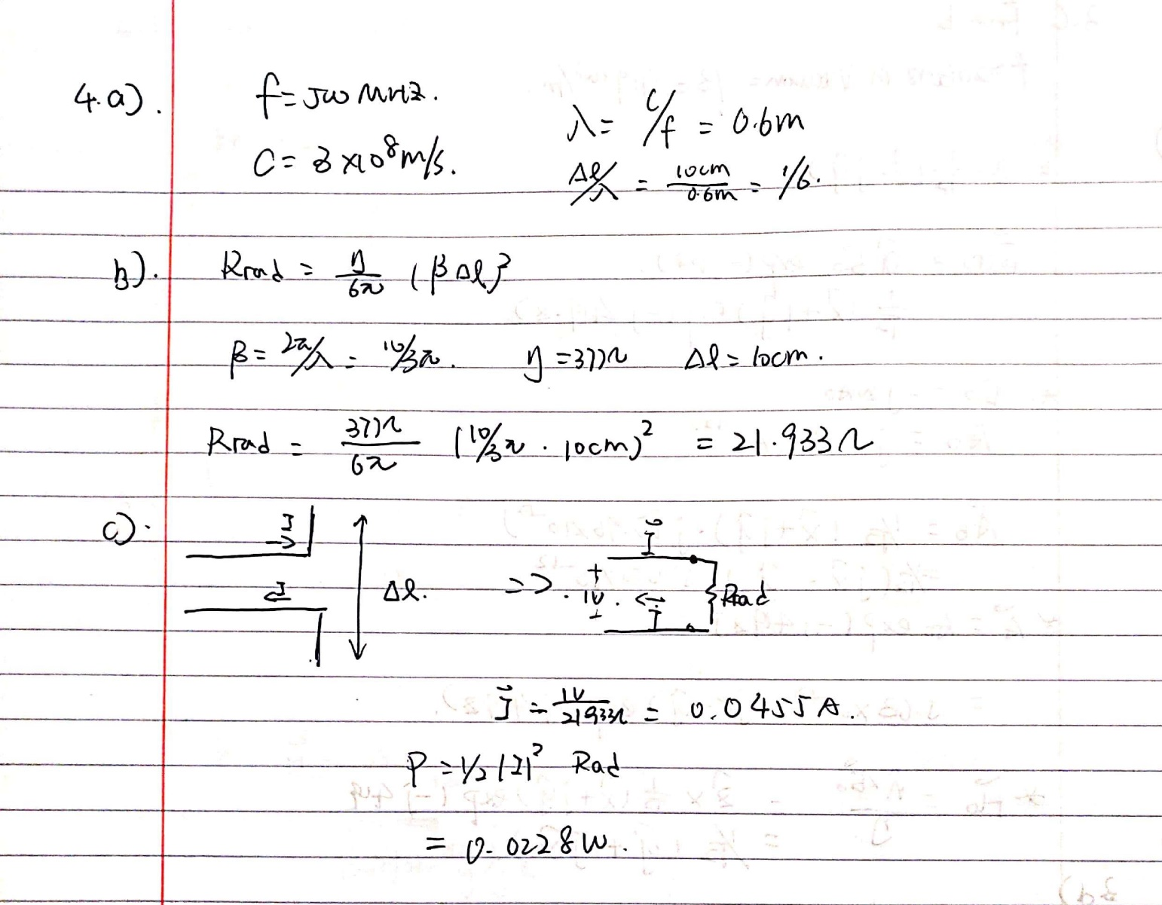

1. **Assume the antenna is oriented along the z axis, located at the origin r0 = (0,0,0), and excited with a voltage phasor V = 1 V. What is the vector potential phasor A, electric field phasor E, magnetic field phasor H, and time average Poynting vector amplitude S at the position 𝐫𝟏 = 100 m 𝐱, at the position 𝐫𝟐 = 100 m 𝐲 and at the position 𝐫𝟑 = 100 m 𝐳 . Consider carefully whether a far-field approximation can be used. Give your answers using Cartesian unit vectors 𝐱, 𝐲 and 𝐳. [4pts]**

Solution for r1 = 100m**x**:

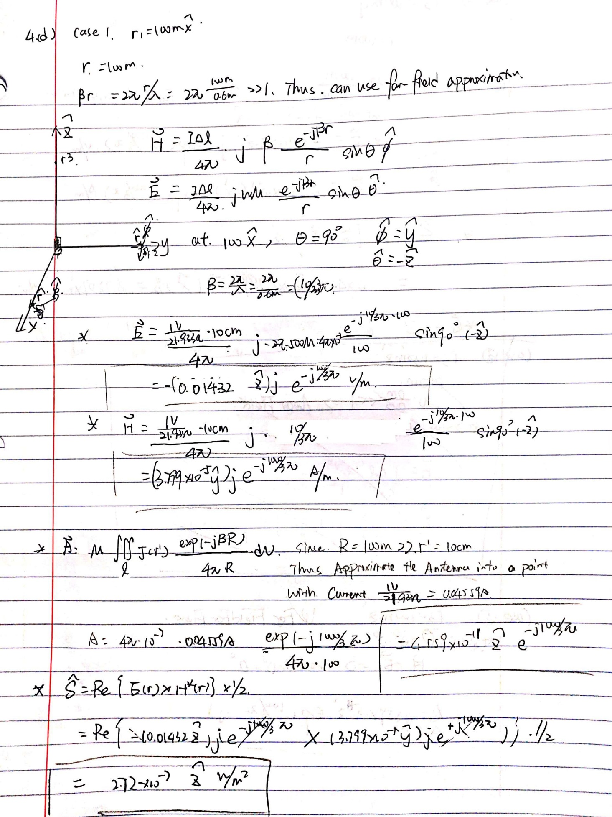

Solution for r2 = 100m**y**:

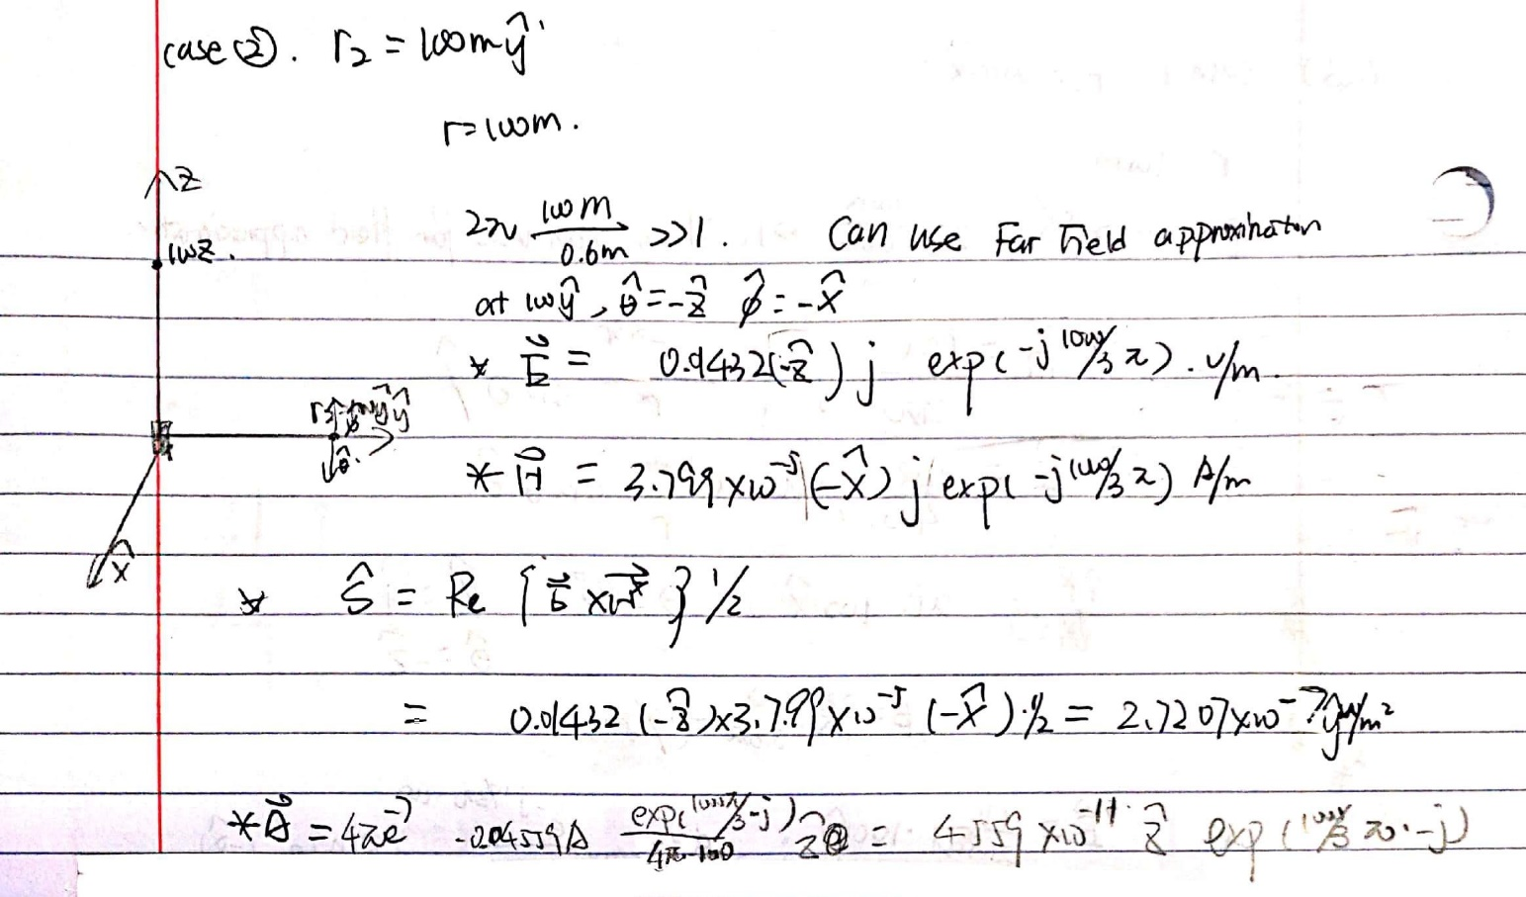

Solution for r3 = 100m**z**:

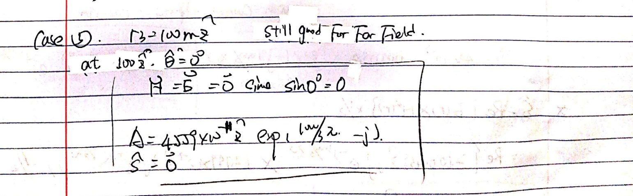

1. **Including reactance, the antenna impedance is ZL = Rrad – j 220 Ω. Design a shorted stub transmission line circuit to achieve an impedance match between a lossless transmission line and the antenna. The transmission line characteristic impedance is Z0 = 100 Ω and the transmission line phase velocity is vp = 2x108 m/s. Provide the distance d between the antenna load and the junction stub, and the length of the shorted stub l. If you find multiple solutions, identify the most physically compact solution. [3pts]**

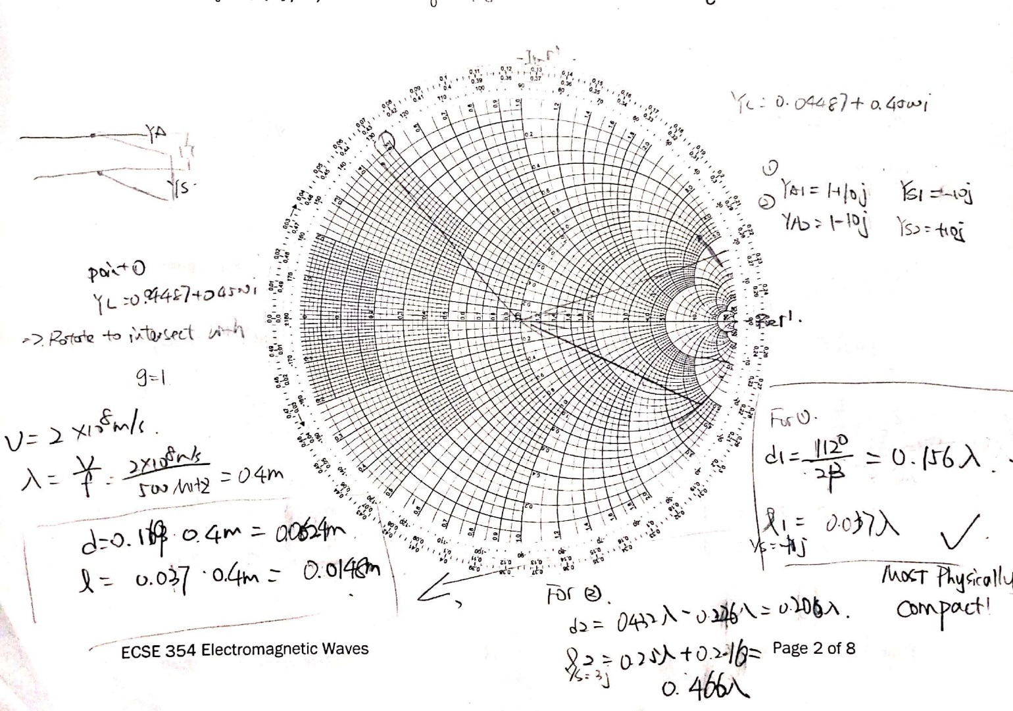

Optional exercise for self-education beyond ECSE 354 (no marks): Consider a Hertzian dipole oriented located at a position 𝐫𝟎 = 𝑧 𝐳 above a perfect electric conductor at the z = 0 plane. Identify the minimum distance and orientation of the dipole that would maximize emission in the vertical (+z) direction. This problem is important for understanding antenna interaction with conductive objects. HINT: consider using the concept of image charge from electrostatics.